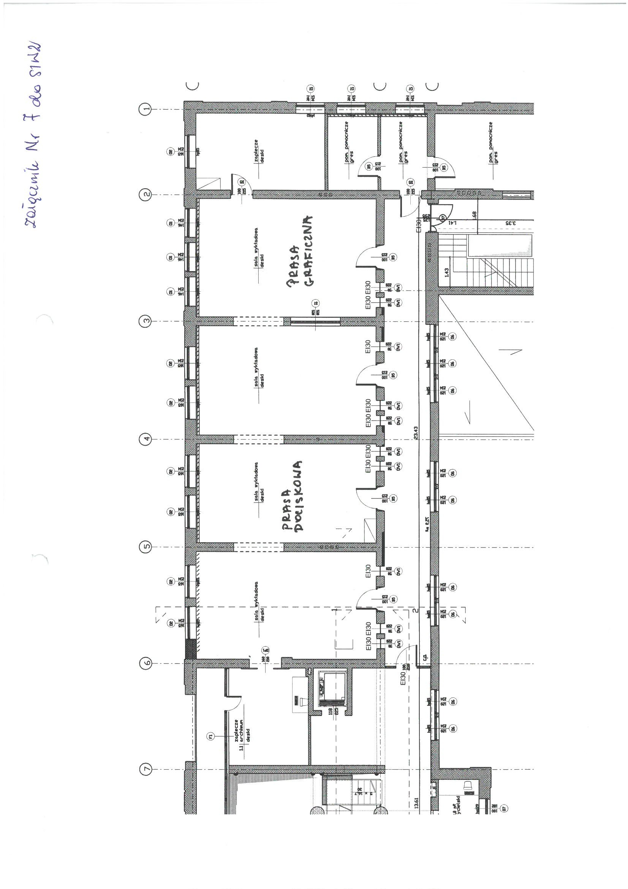

GRAPHIC PRESS

PRESSURE PRESS

ANNEX NO. 7 TO ToR